**Handling User Authentication Output**

**greeting.jsp**

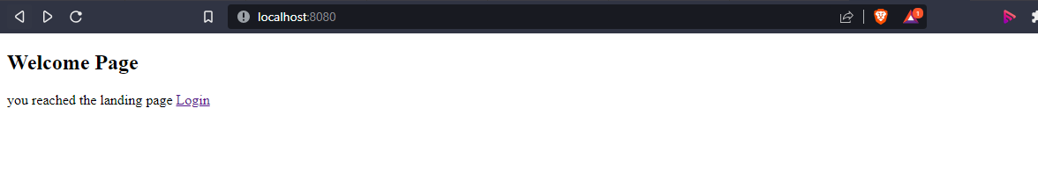

**authenticate.jsp**

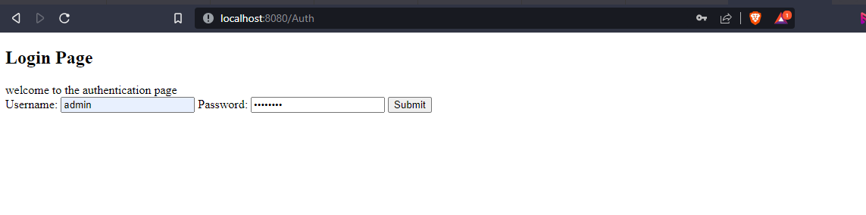

**success.jsp**

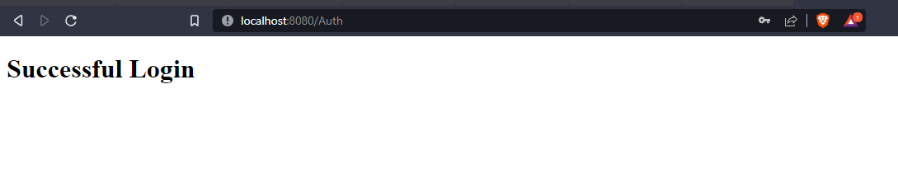

**failure.jsp**

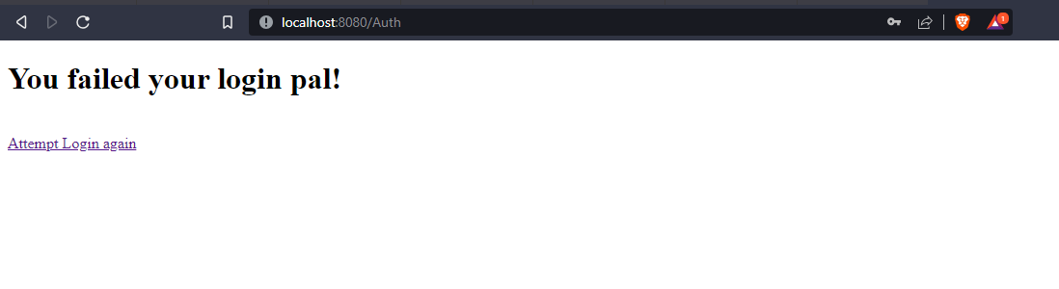

**Junit Test Case**

